# ***Ahsanullah University of Science & Technology***

Department of Computer Science & Engineering



**Hospital Management System**

CSE 3224

Information System Design & Software Engineering Lab

Submitted By:

Shadman Sakib 16.01.04.092

A.K.M. Sadman Ali 16.01.04.093

Tasmia Tuj Juha 16.01.04.095

Mehedi Hasan Abir 16.01.04.102

Date of Submission: **02 April, 2019**

**Contents:**

1) Introduction…………………………………………………………………………………….………………….3

2) Entities……………………………………………………………………………………………………………….4

3) EntityRelationship Diagram……........................................................................................................5

4) Relational Model…………………………………………………………………………………………..…….7

5) SQL commands……………………………………………………………………………………………….......8

6) Dummy Data…………………………………………………………………………………………………..…10

7) Conclusion……………………………………………………………………………………………………..….10

**1) Introduction:**

Our hospital management system will act as a solution to problems such as disorganized hospital management, delayed appointments, lost prescriptions and reports, time wastage etc.

The proposed system provides a superior way of storing patient’s data and keeping track of all sorts of information related to management. And that’s why our project needs to have a well-designed database which will store data in simplified form and maintain the appropriate relationship amongst them. An Entity Relationship Diagram gives a good visual representation of data for database and a Relational Model helps to structure data in a simplified manner.

By using these data modeling tools, we can manage the data very efficiently. Entity Relationship Diagram and Relational Model diagrams will allow us to create a healthy database structure which will have easy storage and retrieval.

**2) Entities**:

Entities are the real or abstract things about which data will be stored. Our project has the following entities:

|  |  |  |
| --- | --- | --- |
| **Entity** | **Primary Key (PK)** | **Foreign Key (FK)** |
| Patient | PatientId |  |
| Doctor | DoctorId |  |
| DoctorSchedule | ScheduleId | DoctorId |
| Appointment | AppointmentId | DoctorId, PatientId, PrescriptionId |
| Prescription | PrescriptionId |  |
| Medicine | MedicineId |  |
| MedicineDetails | PrescriptionId, MedicineId | PrescriptionId, MedicineId |
| Test | TestId | AssistantId |
| Payment | PaymentId | PatientId |
| LabAssistant | AssistantId |  |

Every table has its separate primary key and some of the tables have foreign keys. For example, the DoctorSchedule table has DoctorId as its foreign key. The Appointment table has 3 foreign keys: DoctorId, PatientId and PrescriptionId. MedicineDetails has 2 foreign keys: PrescriptionId, MedicineId. Test has AssistantId as foreign key and Payment has PatientId as foreign key.

**3) Entity Relationship Diagram:**

The Entity Relationship Diagram denotes the relation between entities of a system. The ERD will consist of cardinalities and attributes. Our ERD is given below in two parts:

Part 1:

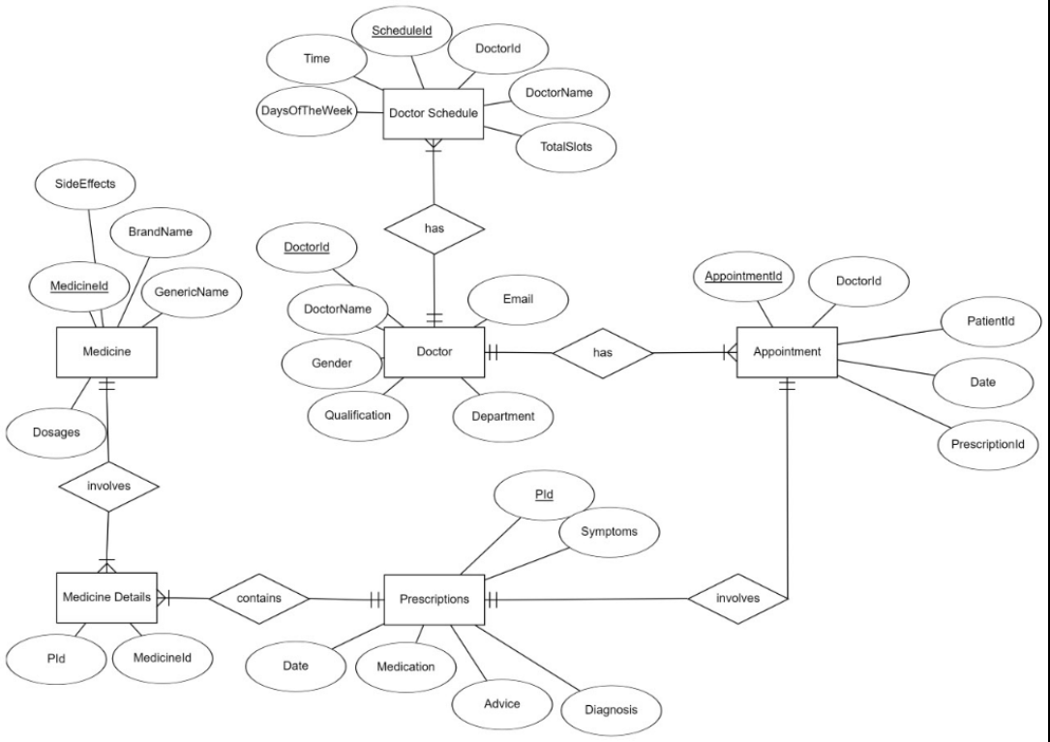

Part 2:

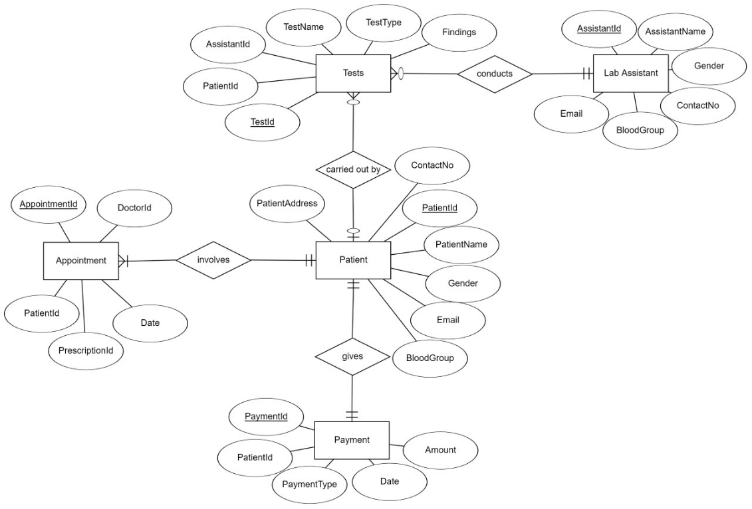

**4) Relational Model:**

The relational model is an approach to managing data using a structure and consistent language. The purpose of the relational model is to provide a method for specifying data and queries.

The relational model for our project is given below:

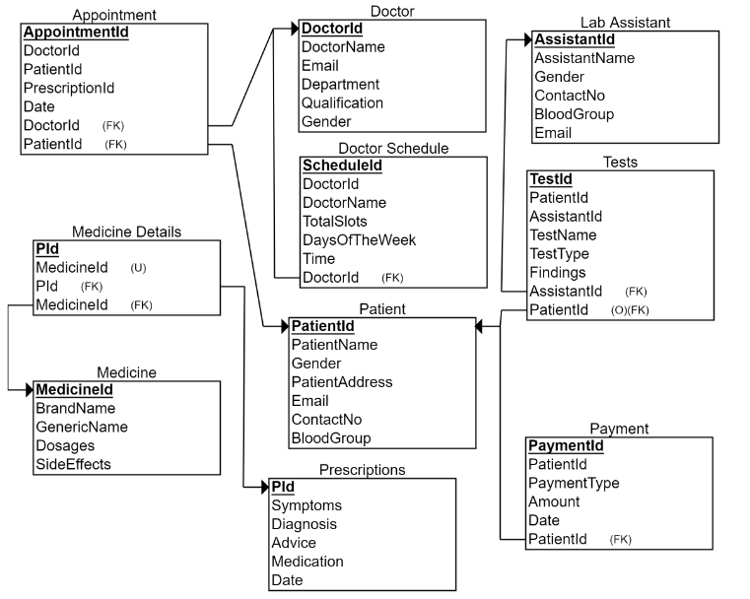

**5) SQL Commands:**

The Entity Relationship diagram helps in creating the corresponding SQL query for the data manipulation purpose. Every relation along with their cardinality in the Entity Relationship diagram is considered while converting to SQL query.

The following are the SQL queries for the Entity Relationship diagram of our project:

CREATE TABLE PATIENT

(

PatientId int primary key identity(1,1),

PatientName varchar(50) not null,

Username varchar(50) unique not null,

Password varchar(50) not null,

Gender varchar(50) not null,

PatientAddress varchar(50) not null,

Email varchar(50) not null,

ContactNo varchar(50) not null,

BloodGroup varchar(50) not null

);

**CREATE TABLE DOCTOR**

(

DoctorId int primary key identity(1,1),

DoctorName varchar(50) not null,

Username varchar(50) unique not null,

Password varchar(50) not null,

Email varchar(50) not null,

Department varchar(50) not null,

Qualification varchar(50) not null,

Gender varchar(50) not null

);

CREATE TABLE MEDICINE

(

MedicineId int primary key identity(1,1),

BrandName varchar(50) not null,

GenericName varchar(50) not null,

Dosages varchar(50) not null,

SideEffects varchar(255)

);

CREATE TABLE DOCTORSCHEDULE

(

ScheduleId int primary key identity(1,1),

DoctorId int foreign key references Doctor(DoctorId),

DoctorName varchar(50) not null,

TotalSlots int not null,

DaysOfTheWeek varchar(255) not null,

Time varchar(255) not null

);

CREATE TABLE PRESCRIPTION

(

PId int primary key identity(1,1),

Symptoms varchar(255) not null,

Diagnosis varchar(255) not null,

Advice varchar(255) not null,

Medication varchar(255),

Date varchar(255) not null

);

CREATE TABLE TEST (

TestId INT IDENTITY (1, 1) NOT NULL,

PatientId INT NOT NULL foreign key references Patient(PatientId),

AssistantId INT NOT NULL foreign key references LabAssistant(AssistantId),

TestName VARCHAR (255) NOT NULL,

TestType VARCHAR (255) NOT NULL,

Findings VARCHAR (255) NULL,

);

CREATE TABLE APPOINTMENT

(

AppointmentId INT NOT NULL PRIMARY KEY,

DoctorId INT NOT NULL foreign key references Doctor(DoctorId),

PatientId INT NOT NULL foreign key references Patient(PatientId) ,

PrescriptionId INT NOT NULL foreign key references Prescription(PrescriptionId),

Date DATETIME NOT NULL,

)

CREATE TABLE LABASSISTANT(

AssistantId INT IDENTITY (1, 1) NOT NULL,

AssistantName VARCHAR (50) NOT NULL,

Gender VARCHAR (50) NOT NULL,

ContactNo VARCHAR (50) NOT NULL,

BloodGroup VARCHAR (50) NOT NULL,

Email VARCHAR (255) NOT NULL,

);

CREATE TABLE PAYMENT

(

PaymentId INT NOT NULL IDENTITY(1,1) PRIMARY KEY,

PatientId INT NOT NULL foreign key references Patient(PatientId),

PaymentType VARCHAR(10) NOT NULL,

Amount INT NOT NULL,

Date DATETIME NOT NULL,

)

CREATE TABLE MEDICINEDETAILS

(

PId INT NOT NULL,

MedicineId INT NOT NULL,

PId INT NOT NULL,

MedicineId INT NOT NULL,

PRIMARY KEY (PId),

FOREIGN KEY (PId) REFERENCES Prescriptions(PId),

FOREIGN KEY (MedicineId) REFERENCES Medicine(MedicineId),

UNIQUE (MedicineId)

);

**6) Dummy Data:**

Some dummy data are inserted here for justifying the multiplicities specified in the ER diagram.

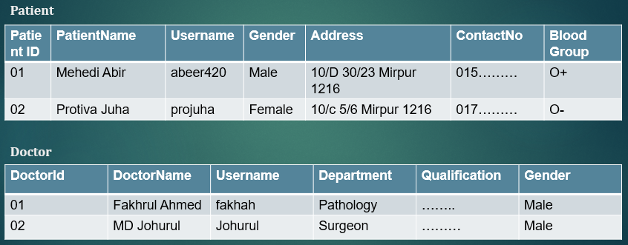

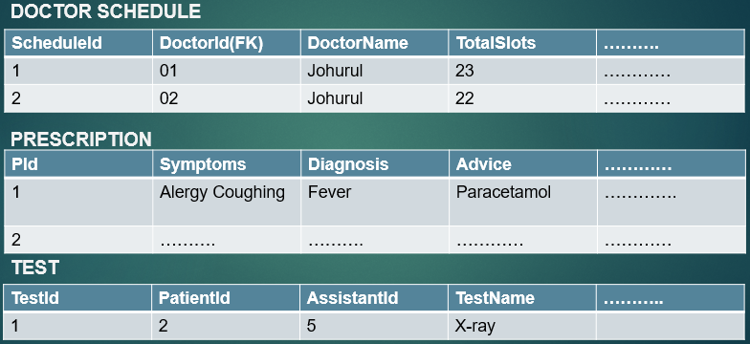

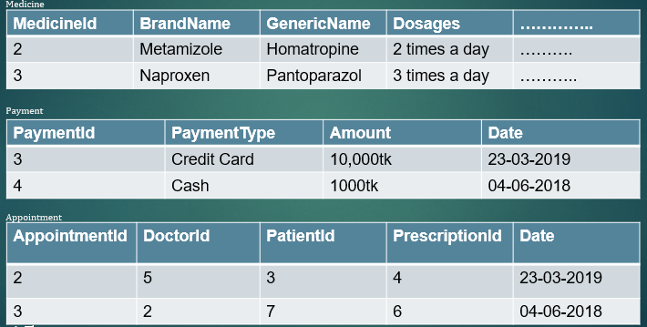

**7) Conclusion:**

The ERD and Relational Model helped us to understand how the database will be implemented. SQL commands allowed us to make data tables according to the model. By finding the proper Entity Relationship diagram and by converting it properly corresponding SQL queries we were able to build an efficient database for our Hospital Management System. Hence, our project has moved further towards completion.